Summer Half Term Activities

Monday 25th July  Boxing session | Tuesday 26th July  This Photo by Unknown Author is licensed under CC BY-SA  Bring something with wheels! (don’t forget  your helmets!) | Wednesday 27th July  This Photo by Unknown Author is licensed under CC BY  Jumping fun on the bouncy castle! | Thursday 28th July  Sports day! | Friday 29th July  Rounders match!!
Week One

There will be other activities throughout the day!
Week Two
Monday 1st August  Bourne park for some splashing fun! (Bring your swimming suits and towel!) | Tuesday 2nd August  Boxing Session! | Wednesday 3rd August  Swimming pool day! (Bring your swim suits & towels) | Thursday 4th August  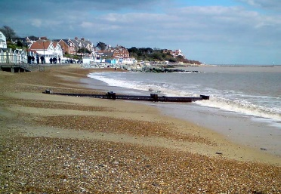  This Photo by Unknown Author is licensed under CC BY-SA  Trip to Felixstowe! (By train!) | Friday 5th August  Let’s have a water fight!  (Please bring spare clothes!)

There will be other activities throughout the day!
Week Three

Monday 8th August  This Photo by Unknown Author is licensed under CC BY-NC-ND  Cake off! Which team can make the best cake! | Tuesday 9th August  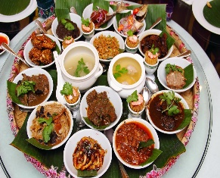  This Photo by Unknown Author is licensed under CC BY-NC-ND  Trying different cultural foods! | Wednesday 10th August  Italian Day! | Thursday 11th August  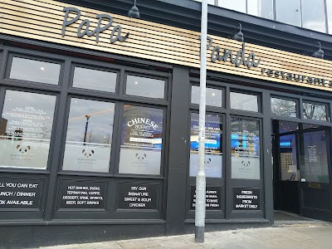  Lunch at Papa pandas! | Friday 12th August  Let’s have a BBQ!
Week Four

Monday 15th August  Making musical instruments! | Tuesday 16th August  Musical crafts! | Wednesday 17th August  Put on a dance show! | Thursday 18th August  Boxing session! | Friday 19th August  Dance session with Sophie!

There will be other activities throughout the day!

Week Five
Monday 22nd August  Owl trail lets go find some owls! | Tuesday 23rd August  Park & Picnic! | Wednesday 24th August  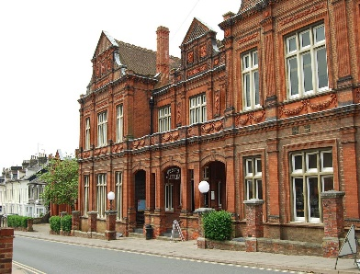  Let’s go explore the Ipswich Museum! | Thursday 25th August  Drumming class and more | Friday 26th August  Boxing Session!

Week Six
Tuesday 30th August  Boxing Session | Wednesday 31st August  End of term party!

